

**Project Report**



.

**Contents**

1. Definition of the Problem…..…………………..………………………………..………………………………….3

2. Requirement Analysis………………………………………………………..…..…………………………………..5

3. Design Phase…………….………………………………...…..………………………………....……..……………….6

4. Architecture of Application……………………..…………………………………………………………………8

Flowchart/…………………….…………………………………………………………………………………........9

Entity Relationship (ER) Diagram……………………..…………………………………………………..10

5. Evaluation/Testing……………………..………………………………………………………………..…………11

6. Documentation Section……………………..………………………………………………………………...…..11

1. List of inputs to the system:………………………..……………………………………………………..12

2. List of outputs expected from the system:……………………..…………………………………...12

3. Overview of Processes involved in the system:……………………..……………………………13

4. Hardware and Software required for implementing the project:……………………....……13

7.Source Code……………………..….……………………………..……………………………………………………14

8. User Guide……………………..………………………………...……………………………………………………..16

**Table of Figures**

Figure 4. 1 Architecture Diagram……………………………………………………………………………..……….. 8

Figure 4. 2 Flowchart Diagrm……………………………………………………………………………………………. 9

Figure 4. 3 ERD (Entity Relationship Diagram)…………………………………………………………………10

Figure 7. 1 Header Source Code…………………………………………………………………………………………………….14

Figure 7. 2 Home Gallery Source Code…………………………………………………………………………………………...14

Figure 7. 3 About Us Source Code………………………………………………………………………………………………….15

Figure 7. 4 Product Section Source Code………………………………………………………………………………………..15

# 1. Definition of the Problem

People are finding it difficult to go through the dizzying array of design alternatives, furnishings, and décor items as modern house interiors continue to gain appeal. With people routinely visiting many platforms to acquire information about designers, products, and pricing, choosing the appropriate mix can get challenging.

In order to solve this problem, the "HomeStyler" website acts as a central location where visitors may look through a variety of interior design options, from carefully chosen collections to popular styles. Apart from offering inspiration, the platform gives customers access to comprehensive profiles of licensed interior designers, enabling them to examine their work history, portfolios, and price information. This makes it simpler for people to locate the ideal designer and get ideas from actual projects.

Additionally, "HomeStyler" provides a thorough breakdown of project costs, enabling users to budget for different designs and accessories. This feature makes it possible for people to budget more wisely, giving them the assurance to confidently plan and carry out their home décor initiatives. "HomeStyler" streamlines the entire process of interior design for homes by fusing useful tools for cost control with inspiring design ideas.

**Proposed Solution**

The answer is to develop the "HomeStyler" website, which provides visitors with a centralized location to find and examine a variety of inspirations and elements for interior design. To assist customers in improving the interiors of their homes, the website will offer a vast array of design images, accessories.  
  
Important features will include comprehensive search, sort, and filter functions to streamline the choosing process, as well as the option to check costs of various designs and accessories. Furthermore, HomeStyler will offer comprehensive profiles of qualified interior designers, providing consumers with simple access to their rates, experiences, and portfolios for comparison and decision-making.

# 2. Requirement Analysis

* **List of inputs to the system:**
* Registration
* Log
* Submit Feedback
* Search for Designs and Products
* Browse and Filter Products
* **List of outputs expected from the system:**
* View Design Styles
* View Product Listings
* View Designer Profiles
* View and Manage Cart
* Search and Filter Results
* Feedback Report
* Sitemap
* **Overview of processes involved in the system:**
* User Login
* Browse and Filter Design Styles
* View Designer Profiles and Product Listings
* Add to Cart
* Provide Feedback
* **Hardware required for implementing the project:**
* Intel Pentium or higher
* 2 GB RAM or above
* Standard VGA Display
* 50 GB Hard Disk
* Mouse and Keyboard
* **Software required for implementing the project:**

#### **Technologies to be used:**

* + **Frontend:**
    - Html
    - CSS
    - Bootstrap
    - JavaScript
    - jQuery
  + **Other** **Requirements**:

#### **Operating System:**

* + - Windows
    - Linux

#### **Browsers:**

* + - Chrome
    - Mozilla Firefox
    - Edge

# 3. Design Phase

Design phase involves the preparation of the blueprint of the proposed system, which includes following:

* Designing the GUI Standard
* Assigning and Monitoring Tasks

Each phase is discussed in detail.

* **Designing the GUI Standards**

The "HomeStyler" website will be designed using HTML, CSS, JavaScript, and Bootstrap to create a user-friendly interface. Multiple linked pages will maintain a consistent appearance in font style, color, and the design of buttons and controls. This cohesive design will enhance user experience and ensure intuitive navigation, providing an engaging platform for exploring interior design inspirations and products.

* **Assigning and Monitoring Tasks**

#### **Project Title:**

HomeStyler

#### **Team Members**:

Abdul Majeed

Maaz Khan

Muhammad Subhan

Muhammad Saqib Khan

#### **Task Assigning**:

Design by Muhammad Saqib Khan, Abdul Majeed

Program by Muhammad Saqib Khan, Muhammad Subhan, Maaz Khan

Documentation by Abdul Majeed

# 4. Architecture of Application

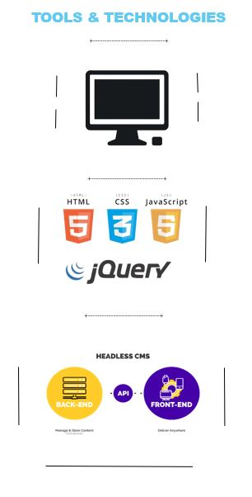

## 

Figure 4. Architecture Diagram

## Flowchart

Figure 4. Flowchart Diagram

### Entity Relationship (ER) Diagram

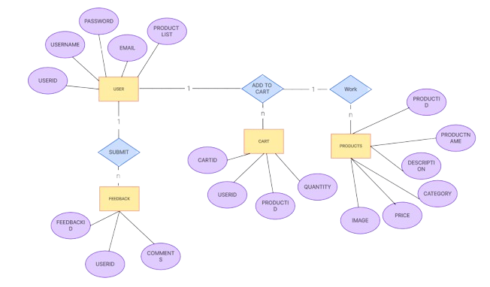

Figure 4. ERD (Entity Relationship Diagram)

# 5. Evaluation/Testing

In the evaluation and testing phase of "HomeStyler", each module is thoroughly tested to ensure it functions as intended. Test data, which may consist of real-world design and product information or dummy data, is used to validate that the system processes inputs and displays outputs without errors. After individual modules are tested, they are integrated and tested as a cohesive unit across various paths to ensure smooth functionality. The project leader will review the website against the defined functional and non-functional requirements to confirm that "HomeStyler" fully addresses the problem definition and meets the user's needs for design inspiration, product selection, and cost management.

# 6. Documentation Section

➢ Various forms required in the project

|  |  |  |
| --- | --- | --- |
| **Design Plan:** | **Document Name:**  **Problem Definition Document** | **SWD/Form No. 1** |
| **Effective Date:** | **Version: 1** | **Page No.** |

**Problem Definition**

By providing a unified platform for visitors to explore carefully curated interior design collections and popular trends, the "HomeStyler" website streamlines the often-daunting process of researching design alternatives, furniture, and décor. To assist consumers in selecting the best expert, it offers in-depth profiles of licensed interior designers that highlight their experience, qualifications, and prices. Furthermore, the platform provides a comprehensive analysis of project expenses, empowering customers to plan their home décor projects with confidence and effectiveness. Through the integration of useful cost management features with inspiring design, "HomeStyler" streamlines and simplifies the process of interior design for homes.

|  |  |
| --- | --- |
|  | **Prepared By (Student) Abdul Majeed, Maaz Khan, Muhammad Saqib Khan, Muhammad Subhan** |
| **Date** | **20-September-2024** |

|  |  |  |
| --- | --- | --- |
| **Design Plan:** | **Document Name: Customer**  **Acceptance Criteria (CRS)** | **SWD/Form No. 2A** |
| **Effective Date:** | **Version: 1** | **Page No.** |

**Client/Project Undertaken:**

It’s hereby that our team “DevSquard” develop and design whole website by our own knowledge, skill and experience.

## 1. List of inputs to the system:

* Registration
* Login
* Submit Feedback
* Search for Designs and Products
* Browse and Filter Products

## 2. List of outputs expected from the system:

* View Design Styles
* View Product Listings
* View Designer Profiles
* View and Manage Wishlist
* Search and Filter Results
* Feedback Report
* Sitemap

## 3. Overview of Processes involved in the system:

* User Login
* Browse and Filter Design Styles
* View Designer Profiles and Product Listings
* Add to Wishlist
* Provide Feedback

## 4. Hardware and Software required for implementing the project:

#### **Hardware:**

*Intel Pentium or higher*

*2 GB RAM or above*

*Standard VGA Display*

*50 GB Hard Disk*

*Mouse and Keyboard*

#### **Software:**

Html

CSS

Bootstrap

JavaScript

# 7.Source Code

**Header HTML Source Code:**

Figure 7. 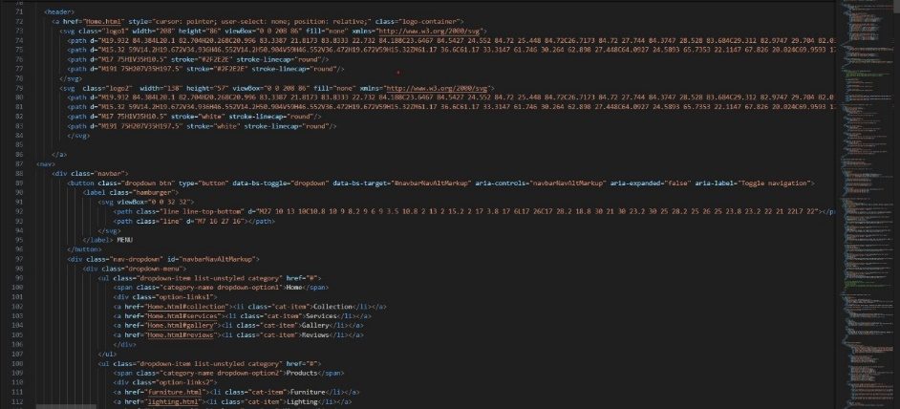 Header Source Code

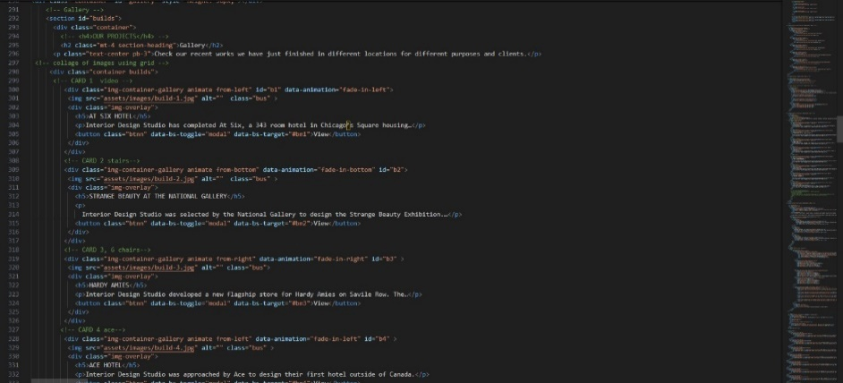**Home Gallery HTML Source Code:**

Figure 7. Home Gallery Source Code

**About Us HTML Source Code:**

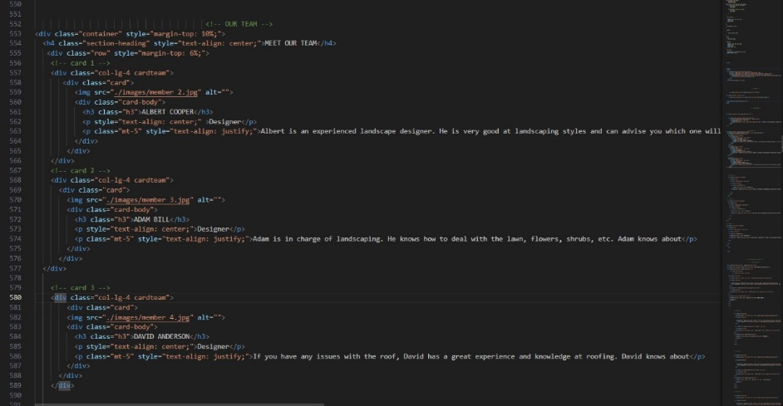

Figure 7. About Us Source Code

**Product (Furniture) HTML Source Code:**

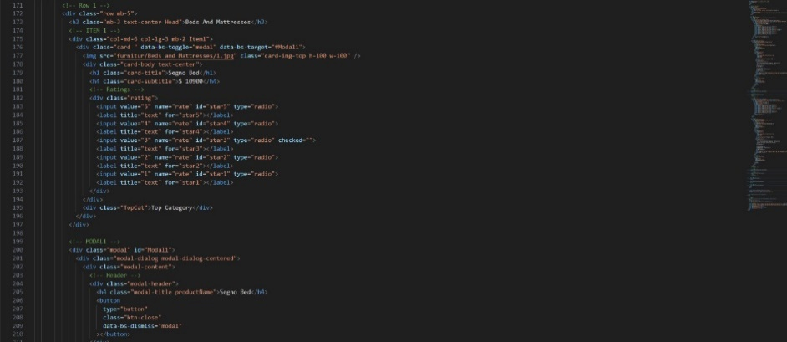

Figure 7. Product Section Source Code

# 8. User Guide

* **System Requirements:**
* **Technologies to be used:**

**Frontend:**

HTML,

CSS,

Bootstrap,

JavaScript,

jQuery,

* **Other Requirements**:

#### **Operating System:**

Windows, Linux

#### **Browsers:**

Edge,

Chrome,

Mozilla Firefox